Math 4 Honors Name ___________________________

HW: Lesson 6-1: *Calculating ARoC* Date ______________________

*Recall:* To analyze trends, we can calculate the average rate of change for a given time interval.

ARoC = 



***Directions:***

1. ***Calculate AROC for each media category. Label each quantity with the correct units.***
2. ***Then indicate if the category is increasing, decreasing or has no change.***

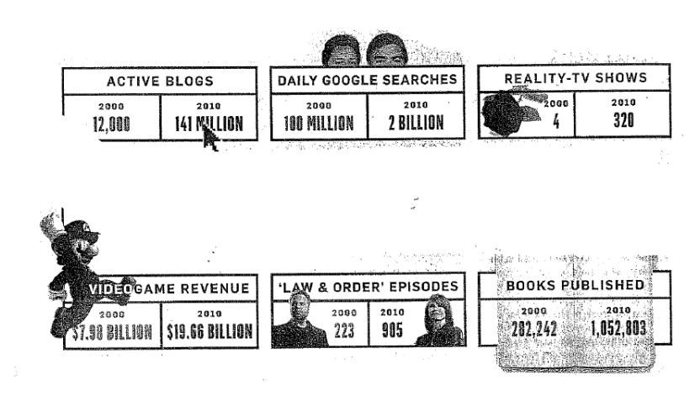

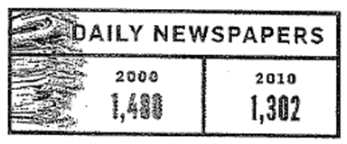

OVER 🡪







